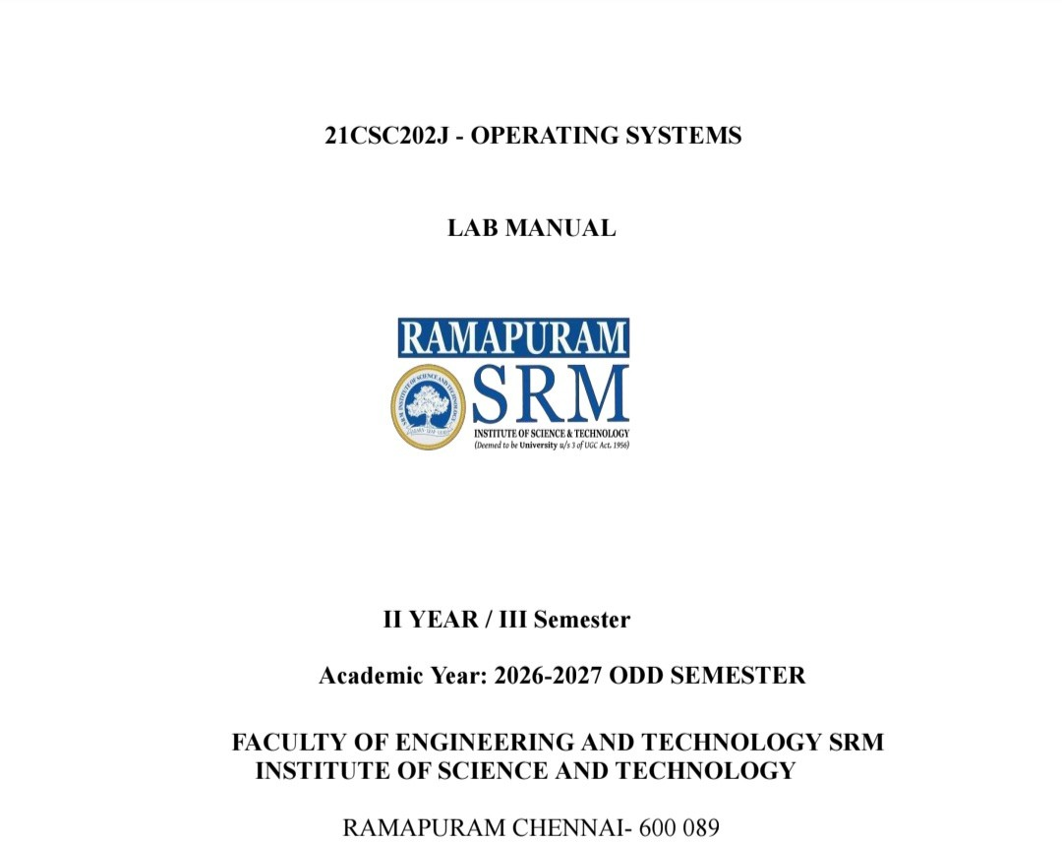

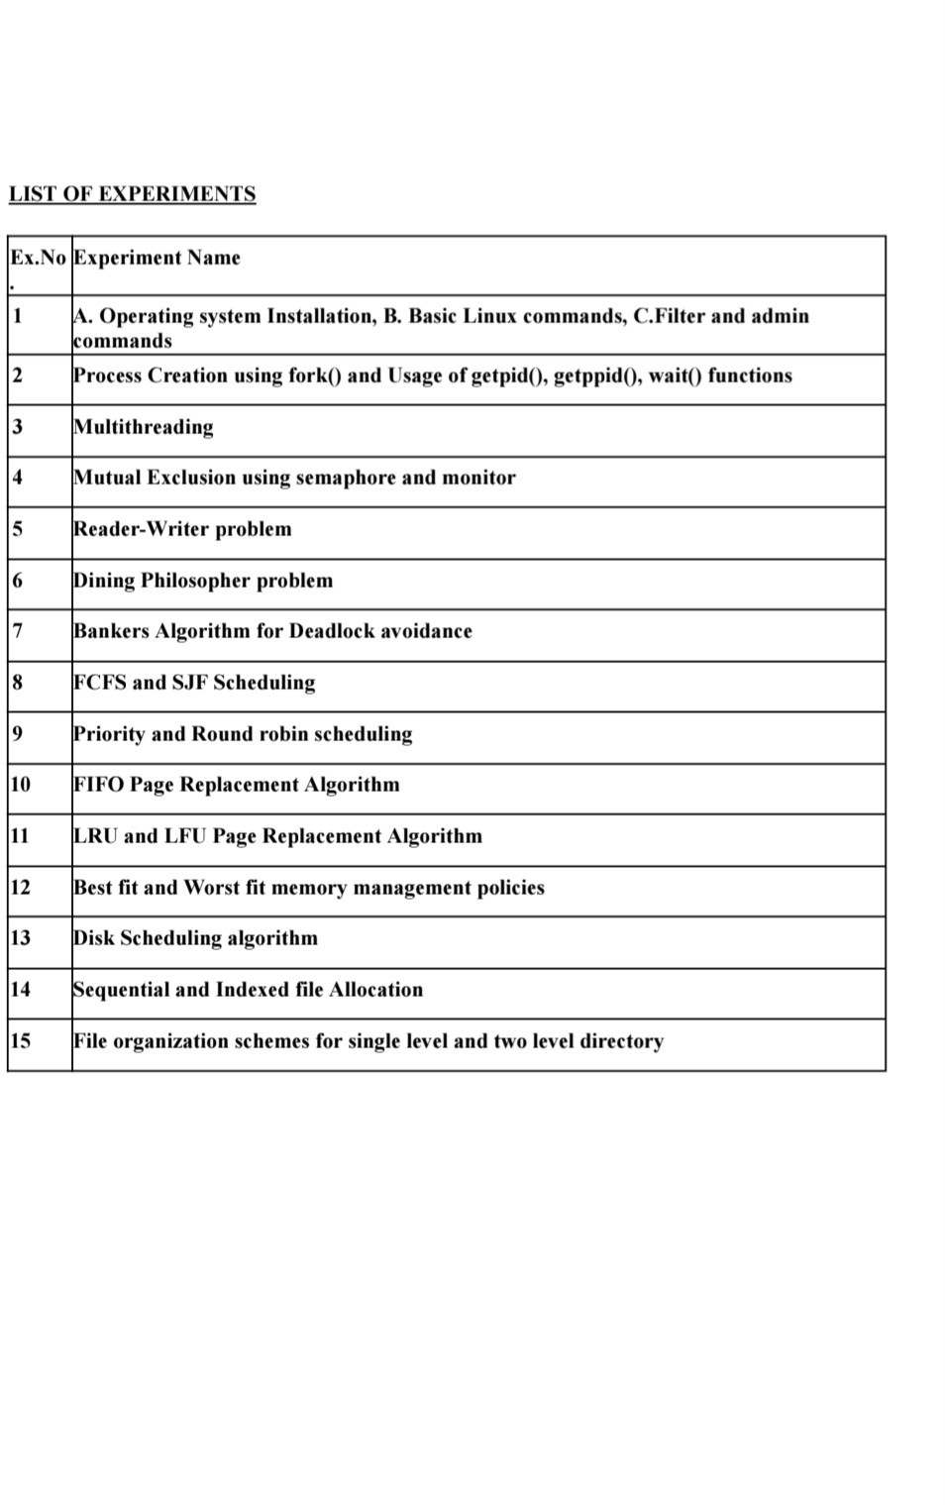

Experiment.No-1BBASIC LINUX COMMANDS

- Basics
  - echo SRM- To display the string SRM
  - clear- To clear the screen
  - date- To display the current date and time
  - cal 2003- To display the calendar for the year 2003 cal 6 2003- To display the calendar for June 2003
  - passwd- To change the password

Working with Files
  - ls- List files in the present working directory
ls -l- List files with detailed information (long list) ls -a- List all files including the hidden files
  - cat > f1- To create a file (Press Ctrl+D to finish typing)
  - cat f1- Display the content of the file f1
  - wc f1- List no. of characters, words & lines of a file f1 wc -c f1- List only no. of characters of file f1
wc -w f1- List only no. of words of file f1 wc -l f1- List only no. of lines of file f1
  - cp f1 f2- Copy file f1 into f2
  - mv f1 f2- Rename file f1 as f2
  - rm f1- Remove the file f1
  - head -5 f1- List first 5 lines of the file f1 tail -5 f1- List last 5 lines of the file f1

Working with Directories
  - mkdir elias- To create the directory elias
  - cd elias- To change the directory to elias
  - rmdir elias- To remove the directory elias
  - pwd- To display the path of the present working directory
  - cd- To go to the home directory cd ..- To go to the parent directory
cd -- To go to the previous working directory cd /- To go to the root directory

File name substitution
  - ls f?- List files that start with 'f' & are followed by any one character
  - ls *.c- List files with extension 'c'
  - ls [gpy]et- List files whose first letter is any one of the characters g, p or y and followed by the word et
  - ls [a-d,l-m]ring- List files whose first letter is any one of the characters from a to d and l to m and followed by the word ring

I/O Redirection
  - Input redirection
wc -l < ex1- To find the number of lines of the file 'ex1'
  - Output redirection
who > f2- The output of 'who' will be redirected to file f2
  - cat >> f1- To append more into the file f1

Piping
Syntax: Command1 | Command2
Output of command 1 is transferred to command 2 as input. Finally the output of command 2 is displayed on the monitor.
ex. cat f1 | more- Lists the contents of file f1 screen by screen head -6 f1 | tail -2- Prints the 5th & 6th lines of the file f1

Environment variables
  - echo $HOME- Display the path of the home directory
  - echo $PS1- Display the prompt string $
  - echo $PS2- Display the second prompt string (>)
  - echo $LOGNAME- Login name
  - echo $PATH- List of path names where the OS searches for an executable file

File permission
The chmod command is used to change the access permission of a file.

Method-1
Syntax: chmod [ugo] [+/-] [rwxa] filename u: user, g: group, o: others
+: Add permission, -: Remove the permission r: read, w: write, x: execute, a: all permissions
ex. chmod ug+rw f1 - adding read & write permissions of file f1 to both user and group members.

Method-2
Syntax: chmod octnum file1
The 3-digit octal number represents as follows:
- First digit - file permissions for the user
- Second digit - file permissions for the group
- Third digit - file permissions for others
Each digit is specified as the sum of the following: 4 - read permission, 2 - write permission, 1 - execute permission.
ex. chmod 754 f1 - it changes the file permission for the file as follows:
- Read, write & execute permissions for the user, i.e., 4+2+1 = 7
- Read & execute permissions for the group members, i.e., 4+0+1 = 5
- Only read permission for others, i.e., 4+0+0 = 4
Output:

Experiment.No-1CFILTERS and ADMIN COMMANDS

FILTERS
- cut
Used to cut characters or fields from a file/input.
Syntax: cut -c chars filename cut -f fieldnos filename
By default, tab is the field separator (delimiter). If the fields of the files are separated by any other character, we need to specify it explicitly by the -d option.
cut -d delimitchar -f fields filename

grep
Used to search one or more files for a particular pattern.
Syntax: grep pattern filename(s)
  - Lines that contain the pattern in the file(s) get displayed.
  - Pattern can be any regular expression.
  - More than one file can be searched for a pattern.

sort
Used to sort the file in order.
Syntax: sort filename
  - Sorts the data as text by default.
  - Sorts by the first field by default.
-roption sorts the file in descending order
-ueliminates duplicate lines
-o filenamewrites sorted data into the file filename
-t dcharsorts the file in which fields are separated by dchar
-nsorts the data as numbers
+1nskip the first field & sort the file by the second field numerically

uniq
Displays unique lines of a sorted file.
Syntax: uniq filename
-doption displays only the duplicate lines
-cdisplays unique lines with no. of occurrences

diff
Used to differentiate two files.
Syntax: diff f1 f2
Compares two files f1 & f2 and prints all the lines that are different between f1 & f2.

Questions:
Q1. Write a command to cut characters 5 to 8 of the file F1.
Ans: $ cut -c 5-8 F1
Q2. Display the user ID (UID) of all users in your system.
Ans: $ cut -d: -f3 /etc/passwd
Q3. Check whether the user judith is available in your system using grep.
Ans: $ grep "^judith:" /etc/passwd
Q4. Display the lines of the file F1 that start with SRM.

Ans: $ grep "^SRM" F1
Q5. Sort the file /etc/passwd in descending order.
Ans: $ sort -r /etc/passwd
Q6. Display the unique lines of the sorted file f21. Also display the number of occurrences of each line.
Ans: $ uniq -c f21
Q7. Write a command to display the lines that are common to the files f1 & f2.
Ans: $ grep -xFf f1 f2

Output:

Experiment.No-2Process Creation using fork() and usage of getpid(), getppid(), wait() functions.
Aim: To write a program for process creation using fork() and usage of getpid(), getppid() and wait() functions.

Definitions:
- What is fork()?
fork() is a system call used to create a new child process.

What does getpid() do?
getpid() returns the PID of the current process.

What does getppid() do?
getppid() returns the PID of the parent process.

What is the use of wait()?
wait() makes the parent process wait until a child process terminates.

What does fork() return?
0 → Child process
Positive value → Parent process (child's PID)
-1 → fork() failed

Program 1: Process creation using fork()
#include <stdio.h> #include <sys/types.h> #include <unistd.h> int main()
{
fork();
fork();
printf("Hello World\n");
}

Sample Output:

Hello World Hello World Hello World Hello World

Output:

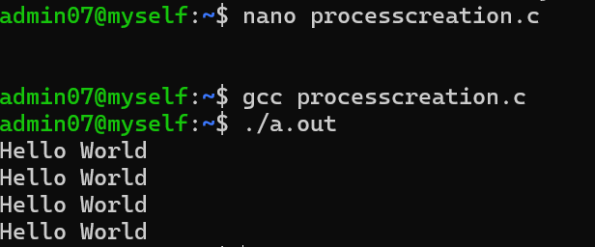

Program 2: Usage of getpid() & getppid()
#include <stdio.h> #include <sys/types.h> #include <unistd.h> void main()
{
// variable to store calling function's process id int process_id, p_process_id;
// getpid() - will return process id of calling function process_id = getpid();
// getppid() - will return process id of parent function p_process_id = getppid();
// printing the process ids
printf("The process id: %d\n", process_id);
printf("The process id of parent function: %d\n", p_process_id);
}

Sample Output:
The process id: 3258
The process id of parent function: 1914

Output:

Program 3: Usage of wait()
#include <stdio.h> #include <stdlib.h> #include <sys/wait.h> #include <unistd.h> int main()
{
pid_t cpid;

if (fork() == 0)
exit(0); /* terminate child */ else
cpid = wait(NULL); /* reaping parent */ printf("Parent pid = %d\n", getpid()); printf("Child pid = %d\n", cpid);
return 0;
}

Sample Output:
Parent pid = 3310 Child pid = 3311

Output:

Result:
Thus successfully completed process creation using fork() and usage of getpid(), getppid() and wait() functions.

Program (4) | Output (3) | Viva (3) | Result (10)

Experiment.No-3Multithreading and Pthread in C
Aim: To implement and study multithreading and pthread in C.

Definitions:
Multithreading: Multithreading is a programming model in which a program creates multiple threads that run concurrently within the same process.
Single threading: Single threading is a programming model in which a program executes one thread of execution. It performs only one task at a time in a sequential order.

Program: (Use case: Web Server)
To create a single thread using pthread.
#include <stdio.h> #include <pthread.h>

// Function executed by the thread void *printMessage(void *arg)
{
printf("Hello from the thread!\n"); return NULL;
}

int main()
{
pthread_t thread;

// Create the thread
pthread_create(&thread, NULL, printMessage, NULL);

// Wait for the thread to finish pthread_join(thread, NULL);

printf("Hello from the main function!\n"); return 0;
}

Sample Output:
Hello from the thread!
Hello from the main function!

Programmatic algorithm:
- Start the program.
- Include the required header files (stdio.h, pthread.h).
- Define a thread function (printMessage) that prints a message.
- Declare a thread variable of type pthread_t.
- Create a new thread using pthread_create(), passing the thread function as an argument.
- The created thread executes the printMessage() function and displays "Hello from the thread!".
- Use pthread_join() to make the main thread wait until the created thread finishes execution.
- After the thread completes, print "Hello from the main function!" from the main thread.
- Return 0 to indicate successful program execution.
- Stop the program.

Output:

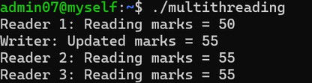

Result:
Thus successfully implemented multithreading and pthread in C.

Program (4) | Output (3) | Viva (3) | Result (10)
Experiment.No-4Mutual exclusion using semaphore and monitor Aim: To implement Mutual Exclusion using semaphore and monitor.

Definitions:
Mutual Exclusion (Mutex): A fundamental rule in concurrent programming stating that only one thread or process can access a shared resource at any given time.
Semaphore: A low-level signaling primitive consisting of an integer counter managed by the operating system (kernel).
Monitor: A higher-level synchronization construct that encapsulates shared data, an internal lock and condition variables into a single module.

Program: (Use case: Automated parking garage with "spots left")
- Semaphore version
#include <stdio.h> #include <pthread.h> #include <semaphore.h>

int spots = 1; // 1 available parking spot
sem_t gate; // Binary semaphore acting as gate lock

void *park_car(void *id)
{
sem_wait(&gate); // Lock gate if (spots > 0) {
spots--;
printf("Car %ld PARKED. Spots left: %d\n", (long)id, spots);
} else {
printf("Car %ld TURNED AWAY (Garage full)\n", (long)id);
}
sem_post(&gate); // Unlock gate return NULL;
}

int main()
{
pthread_t cars[3];
sem_init(&gate, 0, 1); // Gate open for 1 car at a time for (long i = 1; i <= 3; i++)
pthread_create(&cars[i-1], NULL, park_car, (void *)i); for (int i = 0; i < 3; i++)
pthread_join(cars[i], NULL); sem_destroy(&gate);
return 0;
}

Sample Output:
Car 1 PARKED, Spots left: 0
Car 2 TURNED AWAY (Garage Full) Car 3 TURNED AWAY (Garage Full)

Output:

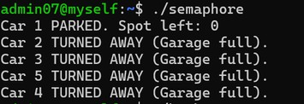

Working Process
- Semaphore Version:
  - Initialize a binary semaphore (sem_t gate) to 1.
  - Threads (representing cars) attempt to acquire access by calling sem_wait(&gate).
  - If a parking spot is available (spots > 0), the thread decrements spots and prints a confirmation.
  - If full, it displays a message indicating the car was turned away.
  - The thread unlocks access via sem_post(&gate).

Monitor version
#include <stdio.h> #include <pthread.h>

int spots = 1; // shared resource
pthread_mutex_t monitor_lock = PTHREAD_MUTEX_INITIALIZER;

// Monitor procedure
void enter_garage(long car_id)
{
pthread_mutex_lock(&monitor_lock); // Entry monitor if (spots > 0) {
spots--;
printf("Car %ld PARKED. Spots left: %d\n", car_id, spots);
} else {
printf("Car %ld TURNED AWAY (Garage full)\n", car_id);
}
pthread_mutex_unlock(&monitor_lock); // Exit monitor
}

void *car_thread(void *id)
{
enter_garage((long)id); return NULL;
}

int main()
{
pthread_t cars[3];
for (long i = 1; i <= 3; i++)
pthread_create(&cars[i-1], NULL, car_thread, (void *)i); for (int i = 0; i < 3; i++)
pthread_join(cars[i], NULL); return 0;
}

Monitor Version:
- Encloses the shared resource access within an entry lock pthread_mutex_lock(&monitor_lock) and exit lock pthread_mutex_unlock(&monitor_lock).
- Only one thread enters the enter_garage procedure at a time to check and update available spots safely.

Sample Output:
Car 1 PARKED, Spots left: 0
Car 2 TURNED AWAY (Garage Full) Car 3 TURNED AWAY (Garage Full)

Output:

Programmatic algorithm:
- Entry phase: The thread requests permission to enter.
- Critical phase: The thread gains exclusive access and executes its operations.
- Exit phase: The thread finishes its work and releases the lock.

Result:
Successfully executed Mutual Exclusion using semaphore and monitor.

Program (4) | Output (3) | Viva (3) | Result (10)

Experiment.No-5Reader-Writer problem Definitions:
Readers: Only read data without modifying it.
Writers: Modify, update or overwrite data.
Aim: To study the reader-writer problem.

Program 1: (Use case: Live stock price board)
#include <stdio.h> #include <pthread.h> #include <semaphore.h>

float stock_price = 150.0;

sem_t rw_mutex; // Writer lock

void *trader_read(void *id)
{
printf("Trader %ld reads price: $%.2f\n", (long)id, stock_price); return NULL;
}

void *admin_write(void *price)
{
sem_wait(&rw_mutex); // Lock out everyone while writing stock_price = *(float *)price;
printf("Admin updated price to: $%.2f\n", stock_price); sem_post(&rw_mutex);
return NULL;
}

int main()
{
pthread_t t1, t2, t3;
float new_price = 155.50; sem_init(&rw_mutex, 0, 1);

pthread_create(&t1, NULL, trader_read, (void *)1); pthread_join(t1, NULL);
pthread_create(&t3, NULL, admin_write, &new_price); pthread_join(t3, NULL);
pthread_create(&t2, NULL, trader_read, (void *)2); pthread_join(t2, NULL);

sem_destroy(&rw_mutex); return 0;
}

Sample Output:
Trader 1 reads price: $150.00 Admin updated price to: $155.50 Trader 2 reads price: $155.50

Programmatic algorithm:
- Initialization: The semaphore is set to 1.
- Trader 1: Reads the current price without locking.
- Admin: Decrements the semaphore to 0, enters the critical section to update the price to $155.5.
- Trader 2: Reads the updated price after the write operation completes safely.

Output:

Working Process

Using Semaphores (Stock Price Board):

Reader threads fetch and display data concurrently without holding exclusive locks.

Writer threads request exclusive access via sem_wait(&rw_mutex).

While the writer updates the shared data, readers are blocked until sem_post(&rw_mutex) is executed.

Using Read-Write Locks (Student Database):

Multiple readers acquire shared locks (pthread_rwlock_rdlock) simultaneously.

A writer acquires an exclusive lock (pthread_rwlock_wrlock), preventing any other thread from reading or writing until completion.

Program 2: (Use case: Student database)
#include <stdio.h> #include <pthread.h> #include <unistd.h>

int marks = 80; pthread_rwlock_t rwlock;

/* Reader function */ void *reader(void *arg)
{
int id = *(int *)arg; pthread_rwlock_rdlock(&rwlock);
printf("Reader %d: Reading marks = %d\n", id, marks); sleep(1);
pthread_rwlock_unlock(&rwlock); return NULL;
}

/* Writer function */ void *writer(void *arg)
{
pthread_rwlock_wrlock(&rwlock); marks = marks + 5;
printf("Writer: Updated marks = %d\n", marks); sleep(1);
pthread_rwlock_unlock(&rwlock); return NULL;
}

int main()
{
pthread_t r1, r2, r3, w1;
int id1 = 1, id2 = 2, id3 = 3; pthread_rwlock_init(&rwlock, NULL);
/* Create reader threads */ pthread_create(&r1, NULL, reader, &id1); pthread_create(&r2, NULL, reader, &id2); pthread_create(&r3, NULL, reader, &id3);

/* Create writer thread */ pthread_create(&w1, NULL, writer, NULL);

/* Wait for all threads */ pthread_join(r1, NULL); pthread_join(r2, NULL); pthread_join(r3, NULL); pthread_join(w1, NULL);

pthread_rwlock_destroy(&rwlock); return 0;
}

Sample Output:
Reader 1: Reading marks = 80

Reader 2: Reading marks = 80
Reader 3: Reading marks = 80 Writer: Updated marks = 85

Programmatic algorithm:
- Start the program.
- Include the required header files.
- Declare a shared variable marks & initialize it to 80.
- Initialize a read-write lock using pthread_rwlock_init().
- Define the reader function.
- Define the writer function.
- In main(), create three reader threads using pthread_create().
- Create one writer thread using pthread_create().
- Wait for all reader and writer threads to complete using pthread_join().
- Destroy the read-write lock using pthread_rwlock_destroy().
- Stop the program.

Output:

Result:
Successfully implemented a solution to the reader-writer problem using mutex, semaphore and read-write lock.

Program (4) | Output (3) | Viva (3) | Result (10)

Experiment.No-6Dining philosophers' problem
The Dining Philosophers problem is a classic thought experiment created by Edsger Dijkstra in 1965 to illustrate the challenges of concurrency, resource sharing, and deadlock in operating systems.
Aim: To implement and study the Dining philosophers' problem.

Program: (Use case: A traffic light controller)
#include <stdio.h> #include <pthread.h> #include <unistd.h>

pthread_mutex_t intersection = PTHREAD_MUTEX_INITIALIZER; // shared lock void *traffic_light(void *direction)

{
pthread_mutex_lock(&intersection); // wait for intersection to clear printf("GREEN: %s traffic moving\n", (char *)direction);
sleep(2); // allows cars through safely printf("RED: %s light stopped\n\n", (char *)direction); pthread_mutex_unlock(&intersection); // release for next direction return NULL;
}

int main()
{
pthread_t t1, t2;
pthread_create(&t1, NULL, traffic_light, "North-South"); pthread_create(&t2, NULL, traffic_light, "East-West");

pthread_join(t1, NULL); // wait for threads pthread_join(t2, NULL);
return 0;
}

Sample Output:
GREEN: North-South traffic moving RED: North-South light stopped GREEN: East-West traffic moving RED: East-West light stopped

Programmatic algorithm:
Main function:
- Create Thread-A running Traffic light Task ("North-South").
- Create Thread-B running Traffic light Task ("East-West").
- Wait for Thread-A to complete.
- Wait for Thread-B to complete.
- Exit program.

Working Process
- Initialize shared resources (represented as a mutex lock intersection).
- Create threads representing competing operations/directions (e.g., North-South and East-West traffic).
- Each thread acquires the mutex (pthread_mutex_lock), executes its task (simulating green light), sleeps for a duration, and releases the mutex (pthread_mutex_unlock).

Output:

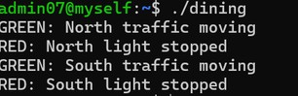

Result:

Thus successfully implemented the concepts of Dining philosophers' problem.

Program (4) | Output (3) | Viva (3) | Result (10)

Experiment.No-7Banker's Algorithm for deadlock avoidance Definitions:
- Banker's Algorithm: A deadlock avoidance algorithm that checks whether granting a resource request keeps the system in a safe state.
- Available: The number of free resource instances currently available.
- Maximum need: The maximum number of resources a process may request.
- Safe state: A state where all processes can complete without causing deadlock.
Purpose: To avoid deadlocks by allocating resources only if the system remains in a safe state.
Aim: To implement and study Banker's Algorithm for deadlock avoidance.

Program 1: (Use case: Print shop server - 3 resources: Printer, Scanner, Plotter)
#include <stdio.h> int main()
{
int avail[3] = {3, 3, 2}, finish[5] = {0}, count = 0;
int max[5][3] = {{7,5,3}, {3,2,2}, {9,0,2}, {2,2,2}, {4,3,3}};
int alloc[5][3] = {{0,1,0}, {2,0,0}, {3,0,2}, {2,1,1}, {0,0,2}};

while (count < 5) { int found = 0;
for (int i = 0; i < 5; i++) { if (!finish[i]) {
int j;
for (j = 0; j < 3; j++)
if (max[i][j] - alloc[i][j] > avail[j]) break; if (j == 3) {
for (j = 0; j < 3; j++) avail[j] += alloc[i][j]; finish[i] = 1;
count++; found = 1;
printf("Job P%d executed\n", i);
}
}
}
if (!found) { printf("Unsafe state\n"); return 0;
}
}
printf("Safe state\n"); return 0;
}

Sample Output:
Job P1 executed

Job P3 executed Job P4 executed Job P0 executed Job P2 executed Safe State

Programmatic algorithm:
Step 1: Start the program.
Step 2: Initialize the available resources.
Step 3: Initialize the Maximum Resource matrix and Allocation matrix. Step 4: Initialize finish[5] = {0,0,0,0,0} & count = 0.
Step 5: Repeat the following steps while count < 5:
- Set found = 0.
- For each process Pi, check whether finish[i] == 0 and Max[i][j] - Alloc[i][j] <= Avail[j] for all resources j. Step 6: If the condition is satisfied:
- Consider process Pi safe to execute.
- Release its allocated resources: Avail[j] = Avail[j] + Alloc[i][j].
- Set finish[i] = 1.
- Increment count.
- Set found = 1.
- Display "Job Pi executed".
Step 7: After checking all processes, if found == 0, display "Unsafe state" & stop. Step 8: If count == 5, all processes have completed successfully. Display "Safe state". Step 9: Stop the program.

Working Process
- Initialize Available resource vector, Max need matrix, Alloc allocation matrix, and finish array.
- Calculate Need = Max - Alloc for each process.
- Iterate through processes: find a process $P_{i}$ where finish[i] == 0 and Need[i] <= Available.
- If found, simulate process execution, release allocated resources (Available += Alloc[i]), set finish[i] = 1, and increment process execution count.
- Repeat until all processes finish or no process can be satisfied.

Output:

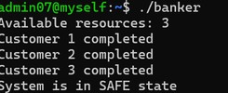

Program 2: (Use case: Bank loan approval)
#include <stdio.h> int main()
{
int available = 3;

int allocation[] = {1, 1, 1};
int need[] = {2, 1, 1}; int n = 3;

printf("Available resources: %d\n", available); for (int i = 0; i < n; i++)
{
if (need[i] <= available)
{
available += allocation[i]; printf("Customer %d completed\n", i + 1);
}
else
{
printf("Customer %d cannot be completed\n", i + 1); printf("System is unsafe\n");
return 0;
}
}
printf("System is in SAFE state\n"); return 0;
}

Sample Output:
Available resources: 3
Customer 1 completed
Customer 2 completed
Customer 3 completed System is in SAFE state

Output:

Result:
Thus successfully implemented the concept of Banker's algorithm for Deadlock Avoidance.

Program (4) | Output (3) | Viva (3) | Result (10)

Experiment.No-8FCFS and SJF Scheduling
Aim: To study the concepts of FCFS and SJF scheduling.

Definitions:

CPU scheduling: Process by which the operating system decides which process in the ready queue gets the CPU for executing.

Non-preemptive and preemptive scheduling:
  - Non-preemptive: Once a process is allocated the CPU, it keeps it until it voluntarily releases it.
  - Preemptive: The OS can interrupt a currently running process and move it back to the ready queue based on priority.

Program: (Use case: Printer Queue) FCFS:
#include <stdio.h>
int main()
{
int n, i;
int bt[10], wt[10], tat[10];

printf("Enter no. of print jobs: "); scanf("%d", &n);

printf("Enter burst time for each print job:\n"); for (i = 0; i < n; i++)
{
printf("Job %d: ", i + 1);
scanf("%d", &bt[i]);
}

// FCFS scheduling wt[0] = 0;
for (i = 1; i < n; i++)
{
wt[i] = wt[i-1] + bt[i-1];
}
for (i = 0; i < n; i++)
{
tat[i] = wt[i] + bt[i];
}

printf("\n--- FCFS PRINT QUEUE SCHEDULING ---\n");
printf("Job\tBurst Time\tWaiting Time\tTurnaround Time\n"); for (i = 0; i < n; i++)
{
printf("J%d\t%d\t\t%d\t\t%d\n", i + 1, bt[i], wt[i], tat[i]);
}
return 0;
}

Output:

Working Process

First-Come, First-Served (FCFS):

Input process burst times.

Process jobs sequentially based on arrival order.

Calculate Waiting Time: $\text{WT}\left[i\right]=\text{WT}\left[i-1\right]+\text{BT}\left[i-1\right]$ (with $\text{WT}\left[0\right]=0$).

Calculate Turnaround Time: $\text{TAT}\left[i\right]=\text{WT}\left[i\right]+\text{BT}\left[i\right]$.

Shortest Job First (SJF):

Sort ready processes by their burst times in ascending order before calculating waiting and turnaround times.

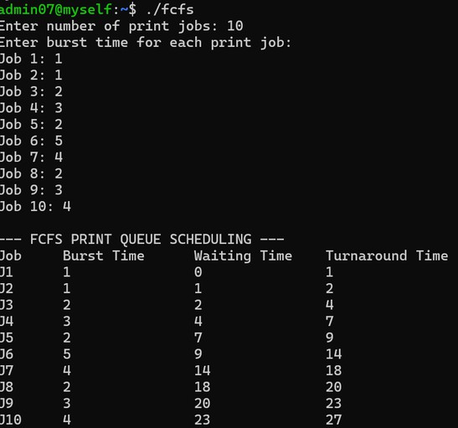

SJF:
(Paste the SJF program and its output here.)

Result:
Thus successfully studied the concepts of FCFS and SJF scheduling.

Program (4) | Output (3) | Viva (3) | Result (10)

Experiment.No-9Priority and Round Robin Scheduling
Aim: To study the concept of priority and round robin scheduling.

Priority Scheduling
Definition: Priority scheduling is a CPU scheduling algorithm where the process with the highest priority is executed first.

Program: (Use case: Hospital Emergency)
#include <stdio.h> int main()
{
int p[] = {1, 2, 3}, pr[] = {3, 1, 2}, i, j, t;
for (i = 0; i < 3; i++)
for (j = i + 1; j < 3; j++) if (pr[i] < pr[j])
{
t = pr[i]; pr[i] = pr[j]; pr[j] = t;
t = p[i]; p[i] = p[j]; p[j] = t;
}
printf("Order: "); for (i = 0; i < 3; i++)
printf("P%d ", p[i]);
}
Sample Output: Order: P1 P3 P2 Output:
Working Process
- Priority Scheduling:
  - Assign priority values to processes.
  - Sort processes based on priority order (e.g., higher numbers indicate higher priority).
  - Execute processes in sorted priority order.
- Round Robin (RR):
  - Define a time quantum $q$ (e.g., $q=2$).
  - Maintain a ready loop over processes.
  - Allocate CPU to each active process for at most $q$ units of time.
  - Deduct executed time from remaining burst time and repeat until all burst times are zero.

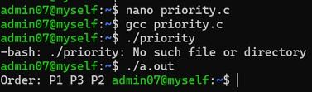

Round Robin Scheduling

Definition: Round Robin is a pre-emptive scheduling algorithm where each process gets a fixed time quantum in turns.

Program: (Use case: CPU Time sharing)
#include <stdio.h> int main()
{
int p[] = {1, 2, 3}, bt[] = {5, 3, 4}, q = 2, i, t = 0;
while (bt[0] || bt[1] || bt[2]) for (i = 0; i < 3; i++)
if (bt[i])
{
int x = bt[i] < q ? bt[i] : q; printf("P%d: %d-%d\n", p[i], t, t + x); t += x;
bt[i] -= x;
}
}

Sample Output:
P1: 0-2
P2: 2-4
P3: 4-6
P1: 6-8
P2: 8-9
P3: 9-11
P1: 11-13
P3: 13-14
P1: 14-15

Output:

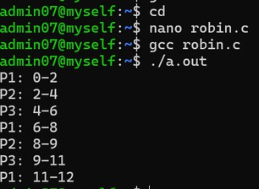

Result:
Thus successfully studied the concepts of priority and round robin scheduling.

Program (4) | Output (3) | Viva (3) | Result (10)
Experiment.No-10FIFO Page Replacement Algorithm Aim: To implement FIFO page replacement algorithm.
Definition: FIFO (First-In, First-Out) page replacement removes the page that entered memory first when a new page needs to be loaded.

Program: (Use case: Queue at a ticket counter)
#include <stdio.h> int main()
{
int p[] = {1, 2, 3, 4, 1}, f[3] = {-1, -1, -1}, i, j, k = 0, hit;
for (i = 0; i < 5; i++)
{
hit = 0;
for (j = 0; j < 3; j++) if (f[j] == p[i])
hit = 1; if (!hit)
{
f[k] = p[i];
k = (k + 1) % 3;
}
printf("Page %d: %d %d %d\n", p[i], f[0], f[1], f[2]);
}
}

Sample Output:
Page 1: 1 -1 -1
Page 2: 1 2 -1
Page 3: 1 2 3
Page 4: 4 2 3
Page 1: 4 1 3

Output:

Working Process

Maintain fixed-size memory frames initialized to empty (e.g., -1) and a pointer $k=0$.

Process page requests one by one from the reference sequence.

If a requested page is present in any frame, it is a hit.

If absent (page fault), place the new page into frame f[k] and update pointer $k=\left(k+1\right) \left(mod \text{frame_count}\right)$.

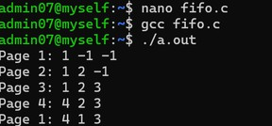

Result:
Thus successfully implemented the FIFO page replacement algorithm.

Program (4) | Output (3) | Viva (3) | Result (10)
Experiment.No-11LRU and LFU Page Replacement Algorithm Aim: To implement page replacement using LRU and LFU.

LRU Page Replacement
Definition: LRU replaces the page that was used least recently.

Algorithm:
- Start with empty frames.
- Read each page from the reference string.
- If the page is already in a frame, update its recent-use position.
- If the page is not present, a page fault occurs.
- If a frame is empty, insert the page.
- Otherwise, replace the least recently used page.
- Repeat until all pages are processed.
- Display the frames and count page faults.

Program: (Use case: A smartphone removes an app/page that has not been used recently when memory is full)
#include <stdio.h> int main()
{
int p[] = {1, 2, 3, 1, 4}, f[3] = {-1, -1, -1}, i, j, pos = 0;
for (i = 0; i < 5; i++)
{
for (j = 0; j < 3; j++)

if (f[j] == p[i]) break; if (j == 3)
{
f[pos] = p[i];
pos = (pos + 1) % 3;
}
printf("%d %d %d\n", f[0], f[1], f[2]);
}
}

Sample Output:
1 -1 -1
1 2 -1
1 2 3
1 2 3
4 2 3

Output:

Working Process
- Least Recently Used (LRU):
  - On a page fault, evaluate frames to find the page that was accessed furthest in the past, and replace it with the new page.
- Least Frequently Used (LFU):
  - Maintain execution counters (c[3]) for each frame.
  - If a page hit occurs, increment its frequency counter.
  - On a page fault, scan counters to locate the frame with the smallest usage count (c[j]), replace its contents, and reset its counter to 1

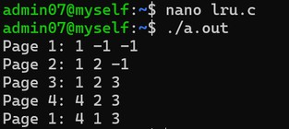

LFU Page Replacement
Definition: LFU (Least Frequently Used) replaces the page that has been used the fewest times.

Algorithm:
- Start with empty frames and frequency counters.
- Read each page from the reference string.
- Check whether the page is already present.
- If present, increase its frequency.
- If absent, a page fault occurs.
- If a frame is empty, insert the page.
- Otherwise, replace the page with the lowest frequency.
- Repeat and display the frames.

Program: (Use case: A streaming app can remove rarely accessed content from its cache to make room for frequently accessed content)

#include <stdio.h> int main()
{
int p[] = {1, 2, 1, 3, 4}, f[3] = {-1, -1, -1}, c[3] = {0}, i, j, pos;
for (i = 0; i < 5; i++)
{
for (j = 0; j < 3; j++)
if (f[j] == p[i]) break; if (j < 3)
c[j]++;
else
{
pos = 0;
for (j = 1; j < 3; j++)
if (c[j] < c[pos]) pos = j;
f[pos] = p[i]; c[pos] = 1;
}
printf("%d %d %d\n", f[0], f[1], f[2]);
}
}

Sample Output:
1 -1 -1
1 2 -1
1 2 -1
1 2 3
1 4 3

Output:

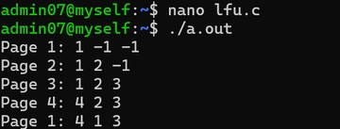

Result:
Thus successfully implemented page replacement using LRU and LFU algorithms.

Program (4) | Output (3) | Viva (3) | Result (10)

Experiment.No-12Best fit and Worst fit memory management policies
Aim: To implement and study best fit and worst fit memory management policies.

Best fit memory allocation
Definition: Best fit allocates a process to the smallest available memory block that is large enough for it.

Algorithm:
- Start with a list of memory blocks and process sizes.
- For each process, search all available blocks.
- Find the smallest block that can accommodate the process.
- Allocate the process to that block.
- Calculate the remaining space.
- Repeat for all processes.

Program: (Use case: Fitting a small item into the smallest suitable compartment in a storage cabinet, leaving larger compartments for bigger items)
#include <stdio.h> int main()
{
int b[] = {100, 500, 200, 300, 600}, p[] = {212, 417, 112, 426};
int i, j, best;
for (i = 0; i < 4; i++)
{
best = -1;
for (j = 0; j < 5; j++)
if (b[j] >= p[i] && (best < 0 || b[j] < b[best])) best = j;
if (best >= 0)
{
printf("P%d -> B%d\n", i + 1, best + 1); b[best] -= p[i];
}
else
printf("P%d -> Not Allocated\n", i + 1);
}
return 0;
}

Sample Output:
P1 -> B4 P2 -> B2 P3 -> B3 P4 -> B5

Output:

Working Process

Best Fit Allocation:

For each process, scan all available memory blocks.

Find the block with the smallest capacity that satisfies $\text{Block Size}≥\text{Process Size}$.

Allocate process to that block and reduce block capacity accordingly.

Worst Fit Allocation:

For each process, scan all available blocks.

Find the block with the largest available capacity.

Allocate the process if $\text{Block Size}≥\text{Process Size}$ and update remaining block space.

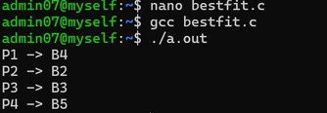

Worst fit memory allocation
Definition: Worst fit allocates a process to the largest available memory block that can accommodate it.

Algorithm:
- Start with a list of memory blocks and process sizes.
- For each process, search all available blocks.
- Find the largest block that can accommodate the process.
- Allocate the process to that block.
- Calculate the remaining space.
- Repeat for all processes.

Program: (Use case: Putting an item into the largest available storage compartment, leaving smaller compartments untouched for small items)
#include <stdio.h> int main()
{
int b[] = {100, 500, 200, 300, 600}, p[] = {212, 417, 112, 426};
int i, j, worst;
for (i = 0; i < 4; i++)
{
worst = -1;
for (j = 0; j < 5; j++)
if (b[j] >= p[i] && (worst < 0 || b[j] > b[worst])) worst = j;
if (worst >= 0)
{
printf("P%d -> B%d\n", i + 1, worst + 1); b[worst] -= p[i];
}
else
printf("P%d -> Not Allocated\n", i + 1);
}
return 0;
}

Sample Output:
P1 -> B5 P2 -> B2

P3 -> B5
P4 -> Not Allocated

Output:

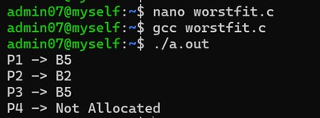

Result:
Thus successfully implemented best fit and worst fit memory management policies.

Program (4) | Output (3) | Viva (3) | Result (10)

Experiment.No-13Disk scheduling algorithm
Aim: To implement and study disk scheduling algorithms.
Definition: Disk scheduling determines the order in which disk I/O requests are served to reduce waiting time and disk head movement.

Algorithm:
- Start from the initial disk-head position.
- Read the pending disk requests.
- Visit each request in the given order.
- Calculate |current - request| for each movement.
- Add all movements to get the total head movement.
- Display the total head movement.

Program: (Use case: A computer hard disk receives requests to access different files stored at different disk locations)
#include <stdio.h> #include <stdlib.h> int main()

{
int a[] = {98, 183, 37, 122, 14, 124, 65, 67}, h = 53, t = 0, i;
for (i = 0; i < 8; i++)
{
t += abs(h - a[i]); h = a[i];
}
printf("Total head movement = %d", t); return 0;
}

Sample Output:
Total head movement = 640

Output:
Working Process
- Read the starting disk head location $h$ (e.g., $53$) and request queue array $a\left[\right]$.
- Iterate through each disk request block $a\left[i\right]$ in order.
- Compute track movement distance: $|h-a\left[i\right]|$.
- Accumulate total head movement: $t=t+|h-a\left[i\right]|$.
- Update current head location $h=a\left[i\right]$ and continue.

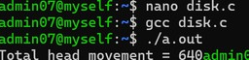

Result:
Successfully implemented various types of disk scheduling algorithms.

Program (4) | Output (3) | Viva (3) | Result (10)

Experiment.No-14Sequential and Indexed File Allocation
Aim: To implement and study sequential and indexed file allocation.

Sequential file allocation
Definition: Sequential file allocation stores a file's blocks one after another in consecutive disk locations.

Programmatic algorithm:
- Start with the first disk block.
- Allocate consecutive blocks for the file.
- Store the file data in these blocks.
- Display the allocated blocks.

Program: (Use case: A video file can be stored in consecutive disk blocks so that its data can be read continuously)

#include <stdio.h> int main()
{
int start = 10, n = 5, i; printf("Sequential Blocks: "); for (i = 0; i < n; i++)
printf("%d ", start + i); return 0;
}

Sample Output:
Sequential Blocks: 10 11 12 13 14

Output:
Working Process
- Sequential Allocation:
  - Define starting block address start and number of contiguous blocks n.
  - Iterate and print contiguous block indices: start + i for $i=0…n-1$.
- Indexed Allocation:
  - Define an index array storing pointers to non-contiguous disk blocks.
  - Iterate through the index block table to output allocated block addresses directly.

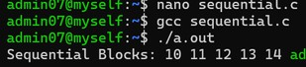

Indexed file allocation
Definition: Indexed file allocation uses a separate index block that stores the addresses of all blocks belonging to a file.

Programmatic algorithm:
- Create an index block.
- Store the addresses of file blocks in it.
- Read the index block.
- Use the stored addresses to access the file blocks.

Program: (Use case: A large database file can use an index block to quickly locate its data blocks without requiring them to be consecutive)
#include <stdio.h> int main()
{
int index[] = {20, 35, 47, 52, 68}, i; printf("Index Blocks: ");
for (i = 0; i < 5; i++) printf("%d ", index[i]);
return 0;
}

Sample Output:
Index Blocks: 20 35 47 52 68

Output:

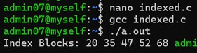

Result:
Thus successfully implemented sequential and indexed file allocation.

Program (4) | Output (3) | Viva (3) | Result (10)

Experiment.No-15FILE ORGANISATION SCHEMES FOR SINGLE AND TWO LEVEL DIRECTORY
Aim: To implement and study file organisation schemes for single and two level directory.

Single level directory
Definition: A single-level directory stores all files in one common directory. Every file has a unique name.

Programmatic algorithm:
- Create a single directory.
- Add files to the directory.
- Display all files.
- Search for a required file by name.

Program: (Use case: Small personal computer that can keep all files in one folder)
#include <stdio.h> int main()
{
char *files[] = {"a.txt", "b.txt", "c.txt"}; int n = 3, i;
printf("Single Directory: "); for (i = 0; i < n; i++)
printf("%s ", files[i]); return 0;
}

Sample Output:
Single Directory: a.txt b.txt c.txt

Output:

Working Process

Single-Level Directory:

Store all file names in a single global directory structure.

Print all files from the shared list.

Two-Level Directory:

Define a Master Directory containing separate directory structures for individual users (e.g., User1, User2).

Store user files inside their respective user directories.

Traverse and print files isolated under each user's space.

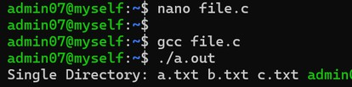

Two level directory
Definition: A two-level directory has a main directory and separate user directories. Each user can have files with the same name.

Programmatic algorithm:
- Create a main directory.
- Create separate directories for each user.
- Store files inside the user's directory.
- Display the files for each user.

Program: (Use case: College computer system can give each student a separate directory)
#include <stdio.h> int main()
{
char *u1[] = {"a.txt", "b.txt", "c.txt"}, *u2[] = {"a.txt"}; printf("User1: %s %s %s\n", u1[0], u1[1], u1[2]); printf("User2: %s\n", u2[0]);
return 0;
}

Sample Output:
User1: a.txt b.txt c.txt User2: a.txt

Output:

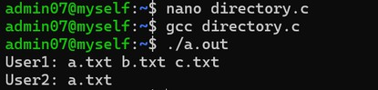

Result:
Thus successfully implemented single level and two level directory file organisation schemes.

Program (4) | Output (3) | Viva (3) | Result (10)

